

**CPE579 Software Design and development project, Phase (4_**

**Project title:** Student Attendance System

**Group names:**

1- Mohammed Al_Za’arir 20100171062

2- Yehya Mubaideen 20102171058

3- Khalid Badarneh 20120171079

**Group #: 3**

**Vision :**

Attendance Management System is a software developed for daily student attendance in our collage . If facilitates to access the attendance information of a particular student in a particular class. The information is sorted by the operators, which will be provided by the teacher for a particular class. This system will also help in evaluating attendance eligibility criteria of a student. and the purpose of developing attendance management system is to computerized the tradition way of taking attendance. Another purpose for developing this software is to generate the report automatically at the end of the session or in the between of the session

The scope of the project is the system on which the software is installed, i.e. the project is developed as a desktop application, and it will work for a particular institute which is Jordan university of since and technology . But later on the project can be modified to operate it online

**Project charter :**

|  |  |
| --- | --- |
| **Project Title**: student attendance system | **Project Manager**: |
| **Start Date**: 8 October 2016 | **Project Sponsor**: |
| **End Date**: 19 December 2016 | **Customer**: facility of Jordan university of since and technology |
| **Purpose (Problem or opportunity addressed by the project)**: we have a lot of problems in the current system which is manually attendance taken by teacher led us to make our new system and I’ll mention some of those problems :   **Not User Friendly:** The existing system is not user friendly  because the retrieval of data is very slow and data is not  maintained efficiently.  **Difficulty in report generating:** We require more calculations to  generate the report so it is generated at the end of the session.  And the student not get a single chance to improve their  attendance   **Manual control**: All calculations to generate report is done  manually so there is greater chance of errors.  **Lots of paperwork**: Existing system requires lot of paper work.  Loss of even a single register/record led to difficult situation  because all the papers are needed to generate the reports.  **Time consuming**: Every work is done manually so we cannot  generate report in the middle of the session or as per the  requirement because it is very time consuming. | |
| Goals and Objectives: The general goal of the project is to create software that will turn an manually student attendace into a new programed automatic system .  **User Friendly:-** The proposed system is user friendly  because the retrieval and storing of data is fast and data is  maintained efficiently. Moreover the graphical user interface  is provided in the proposed system, which provides user to  deal with the system very easily.  **Reports are easily generated:** reports can be easily  generated in the proposed system so user can generate the  report as per the requirement (monthly) or in the middle of  the session. User can give the notice to the students so he/she  become regular.  **Very less paper work:** The proposed system requires  very less paper work. All the data is feted into the computer  immediately and reports can be generated through computers.  Moreover work become very easy because there is no need to  keep data on papers.  **Computer operator control**: Computer operator control  will be there so no chance of errors. Moreover storing and  retrieving of information is easy. So work can be done  speedily and in time. | |
| **Schedule Information (Major milestones and deliverables)**:  15-11-2016 - Iteration #1 Complete 17-11-2016 - Architecture Complete 28-12-2016 - Iteration #2 Complete 8-12-2016 - Iteration #3 Complete  12-12-2016 - System Test Complete 16-12-2016 - Product Released | |
| **Project Priorities and degrees of freedom:** The software must be easy to use and reliable. In a worst-case scenario, maintainability and evolvability may be compromised if it’s the only way to have all high-priority features implemented by the absolute end date. | |
| **Approach:** an incremental approach is planed …We have divided the project for several stages beginning to design interfaces and choose the most appropriate and accessible options could be used to deal with which software and end with the submission of the program integrates serve everyone | |
| **Constraints**: We want to maintain flexibility and minimize dependencies on the regular way to take the attendance | **Assumptions**: the main assume we take is that the whole student will submit their attendance in the same time so our program must be ready for a lot of users and be fast dealing with them  On the technical side , we assume that our program isn’t required to work on other university’s systems |
| **Success Criteria**: 1- the program should work on the system gently  2- the interfaces we choose hoped to be simple and clear for users  The overall project will be deemed a success if the product satisfies our goals and if we finished it by the allocated time | |
| **Scope**: The scope of the project is the system on which  the software is installed, the project is developed as a  desktop application, and it will work for a particular institute. | |
| **Risks and obstacles to success**: 1- a lot of work with no extra time to deal with life situations  2- Shortage of some resources such as an regular data base system  3- difficulty to deal with any additions or to do some Modification on bases | |
| **Signatures (Project Manager, Project Sponsor, Customer, Key contributors to the project)**: | |

**Software Requirements specification :**

**1. Specific Requirements**

**1.1 External Interface Requirements**

1. **User Interfaces** 
   * GUI along with meaningful Frames and buttons
   * Reports are generated as per the requirement
2. **Hardware Interfaces**

|  |  |
| --- | --- |
| Hardware Environment | Dual Core 2nd generation/ |
|  |  |
| System Configuration | RAM-512 MB HDD-80GB |
|  |  |
| Operating system | Windows XP/Vista/7/8/8.1/10 |
|  |  |

**1.1.3 Software Interfaces**

|  |  |
| --- | --- |
| Front End | C# |
|  |  |
| Back End | MySQL 5.1.36 |
|  |  |

When invalid inputs are given to the modules then the error messages will be popped up in order to inform the user that the input provided is not taken by the database. When incomplete information is provided by the user and the user tries to submit the form in order to store the details in the database the system will pop up a message box asking the user to enter all the details required.

**3.1.4 Communications Interfaces**

The machine will have to be part of the college Local area Network to access the central database

**1.02 Functional Requirements**

Student attendance System involves the following functions

* 1. **Student Attendance Management:** 
     + Easily track attendance information of students.
     + Quickly produce single or multiple day attendance bulletins.
     + Fast way to confirm attendance
     + Email in every (10 / 15 /20 ) percentage of dismissing classes

1.2.2 **Teacher management :**

- easily confirm attendance for all students or remove it

- view the whole attendance table at once

- edit specific attendance for specific student

* + - - Email in every (10 / 15 /20 ) percentage of student dismissing classes

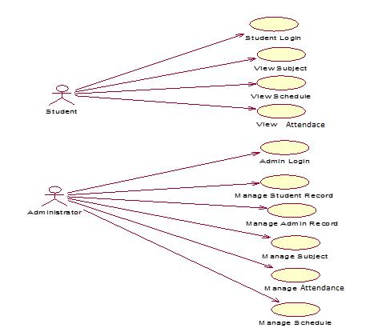

* 1. **Use Cases**

* 1. **Classes / Objects**

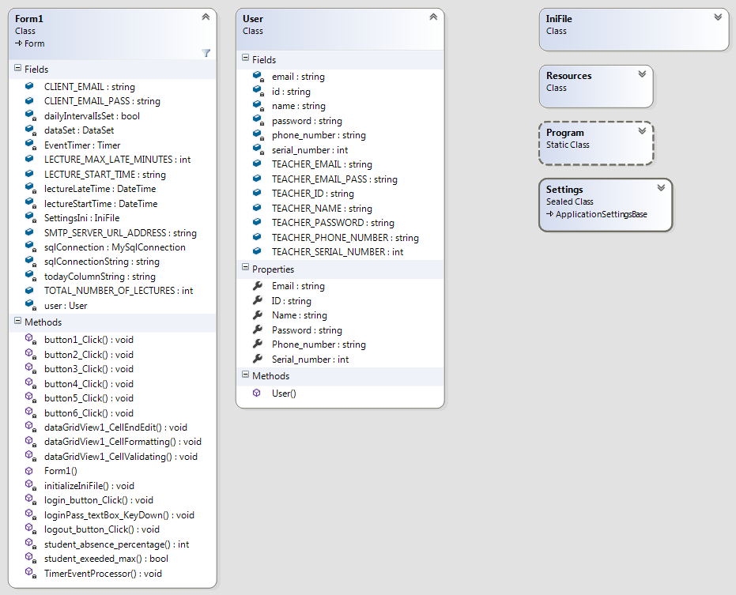

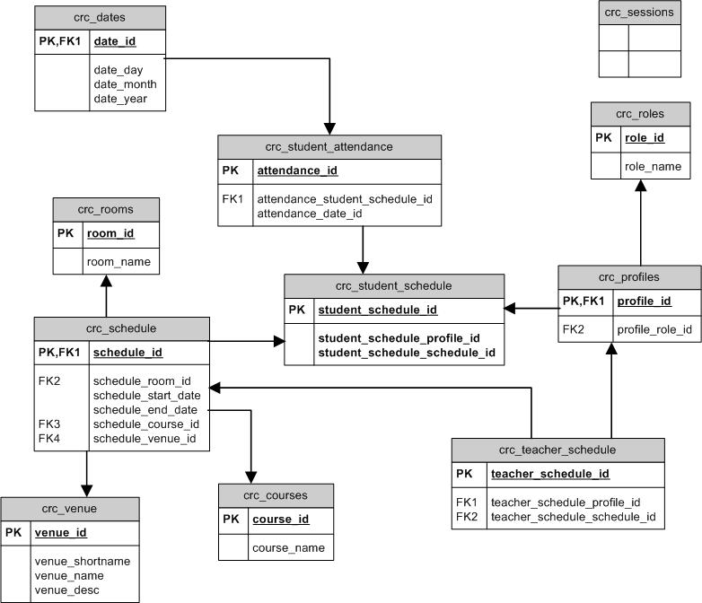



* 1. **Non-Functional Requirements**
  2. **Performance**

Easy tracking of records and updating can be done. All the requirements relating to performance characteristics of the system are specified in the section below. There are two types of requirements.

**A. Static Requirements**

These requirements do not impose any constraints on the execution characteristics of the system. They are:

1. **Number of Terminals:**

The software makes use of an underlying database that will reside at the server,

while the front end will be available to the administrative and departmental computers as well as students and teachers.

**2) Number of Users:**

The number of users may vary, as this software finds applications in almost all department of the organization.

**B. Dynamic Requirements**

These specify constraints on the execution characteristics of the system. They typically include response time and throughout of the system. Since these factors are not applicable to the proposed software, it will suffice if the response tine is high and the transactions are carried out precisely and quickly.

**1.5.2 Reliability**

The software will not be able to connect to the centralized database in the event that the college LAN fails or in the event of the server being down due to a hardware or software failure.

**1.5.3 Availability**

The software will be available only to authorized users of the colleges like teachers to mark the students attendance, student to view their attendance in a certain course

**1.5.4 Security**

The security requirements deal with the primary security. The software should be handled only by the administrator and authorized users. Only the administrator has right to assign permission like creating new accounts and generating password. Only authorized users can access the system with username and password.

**1.5.5 Maintainability**

Backups for database are available.

**1.5.6 Portability**

The Software is a web-based application and is built in C# and MYSQL so it is

platform independent and is independent of operating system.

**1.6 Design Constraints**

This software provides security. The login form prevents the system from being misused by unauthorized users. Only an authorized operator will be granted rights to modify as per requirements. This software is also reliable and fault tolerant. The system developed is designed to handle invalid inputs. Since reliability is major area of concern the system has a backup to avoid data loss. The user should know the programming language very well that is used to develop a software.

**1.7 Other Requirements**

**Database**

All the data will be stored in a relational database

**Data flow diagram :**

First -level DFD:

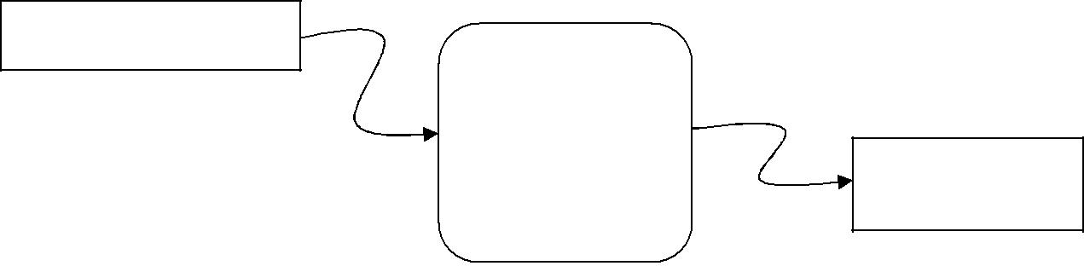

User/Administrator

System

Output

Second -level DFD:

Login

Process

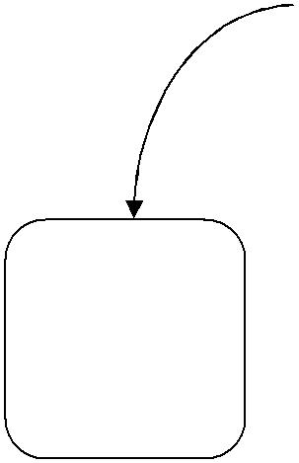

Report

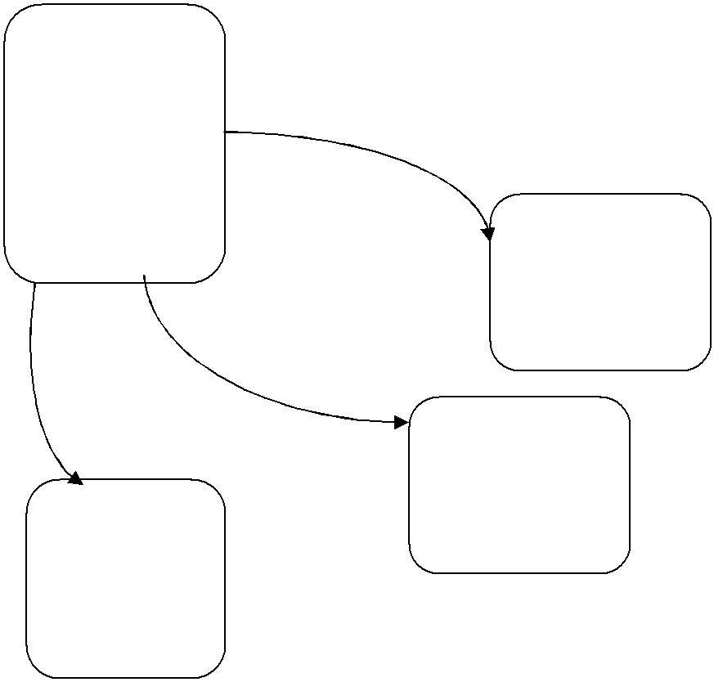

Generation

|  |  |  |
| --- | --- | --- |
| Teacher | Attendance |  |
|  |  |
| Entry | Entry |  |
|  | Student |  |
|  | Entry |  |

Third -level DFD:

3.1:

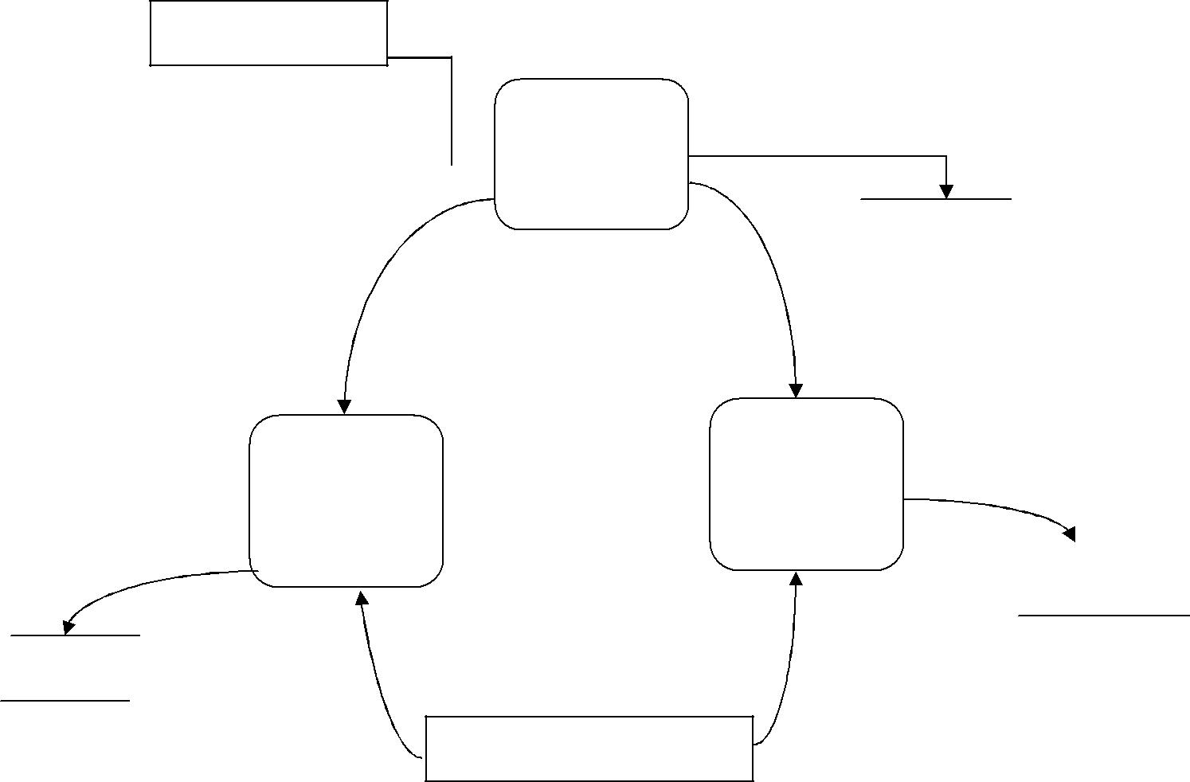

Administrator

Login

 Process

After login

|  |  |  |
| --- | --- | --- |
| After | Login |  |
|  |  |
|  |  |

Data Stored

Student

Entry

|  |  |  |
| --- | --- | --- |
| Teacher | Data Stored |  |
|  |  |
| Entry |  |  |
|  | Teacher |  |

Data Entry

Studen

Administrator

Data Entry

3.2

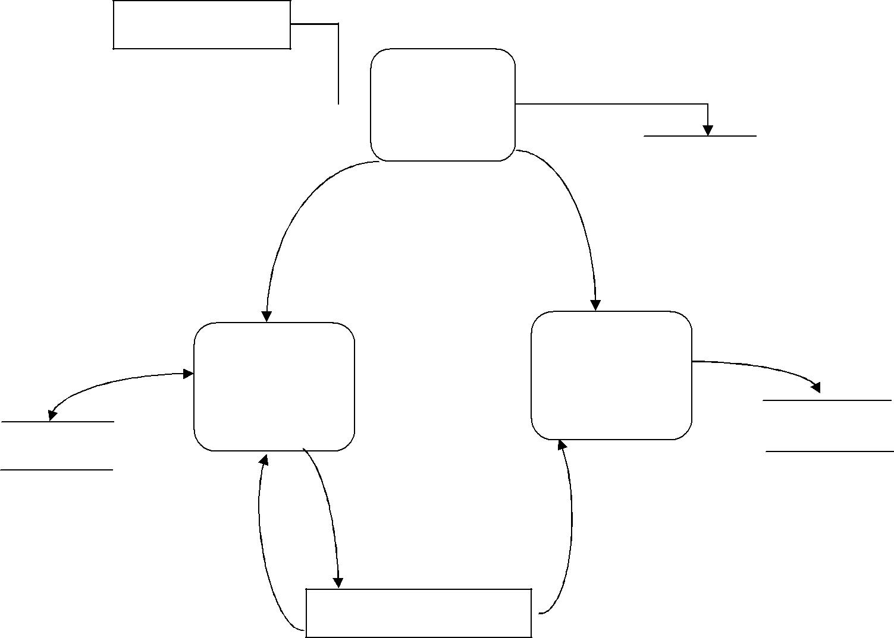

User

Login

 Process

After

Report

Generation

Attendan

Report

User

|  |  |  |
| --- | --- | --- |
| loginAfter | Login |  |
|  |  |
|  |  |

Attendance Data Stored

Entry

Attendance

Data Entry

**Sequence diagram :**

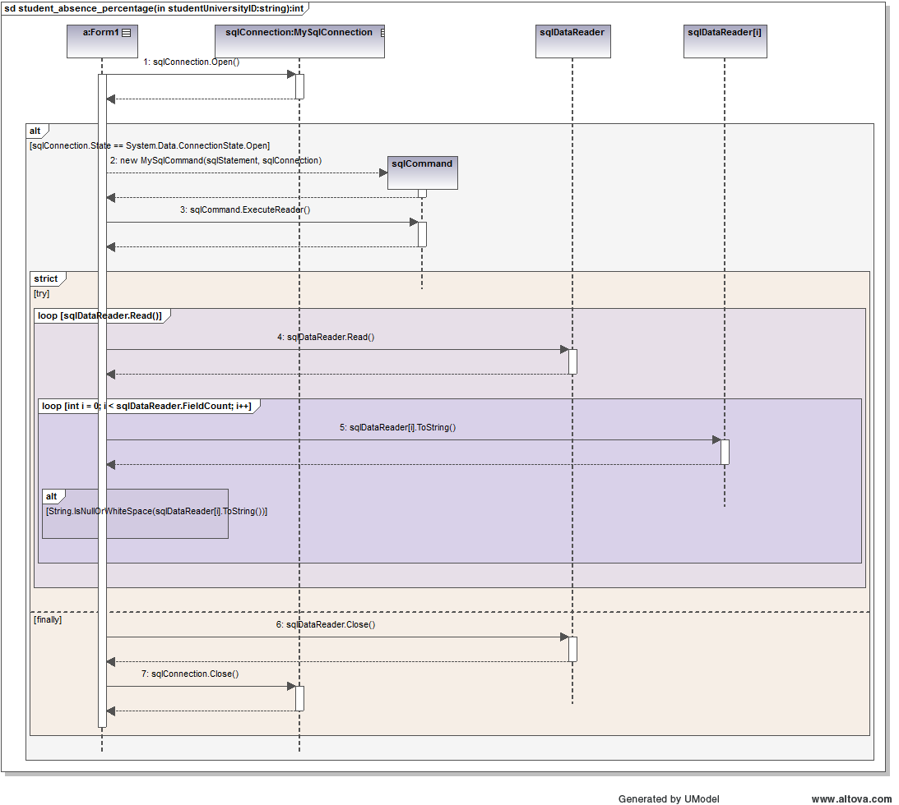

**Database ER Diagram**

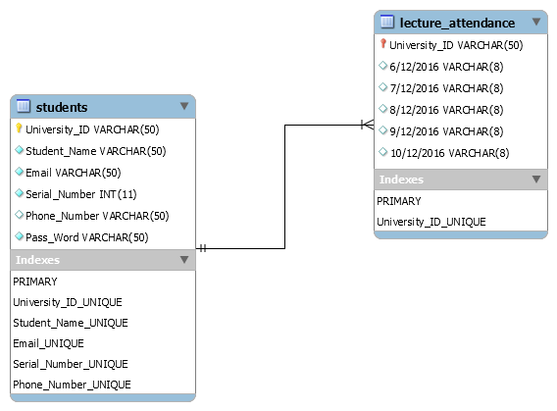

**User Guide :**

1. Home screen to enter your ( Id , Password ) then press login button

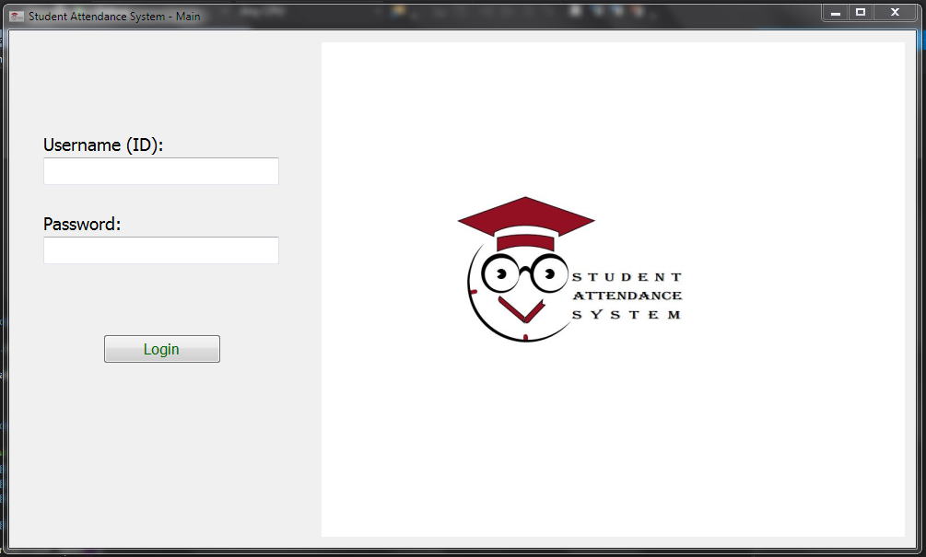

1. You will see this screen and you have these options
2. Confirm attendance
3. Logout
4. Show your attendace

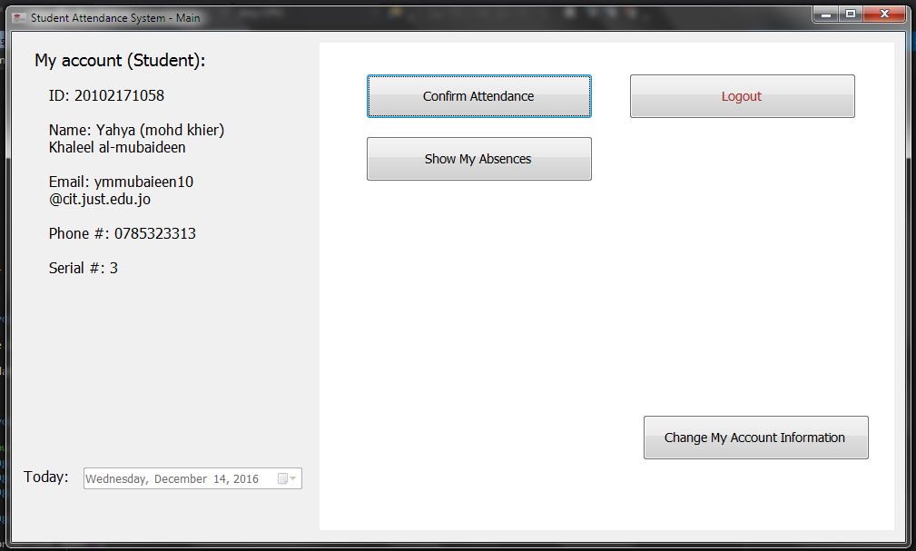

1. If you login as a teacher (admin ) you will see this screen and options 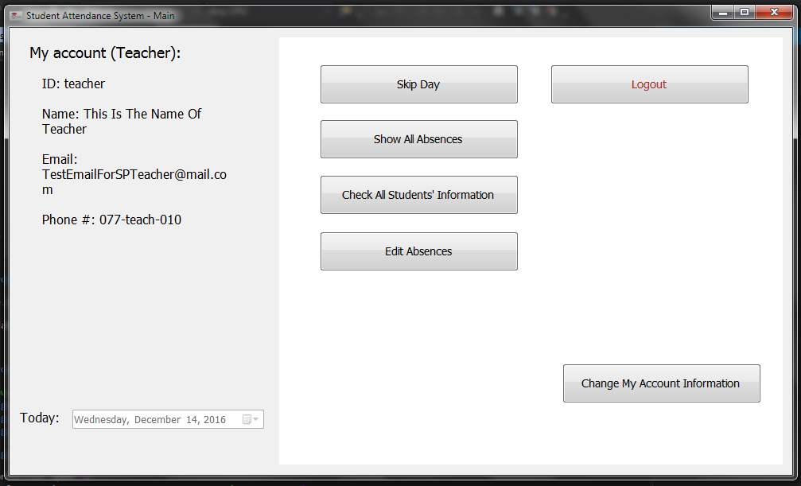

You can ( skip day , show all students attendance ,check their information , edit absence , change information )

1. Some errors and exceptions
2. Error if empty box

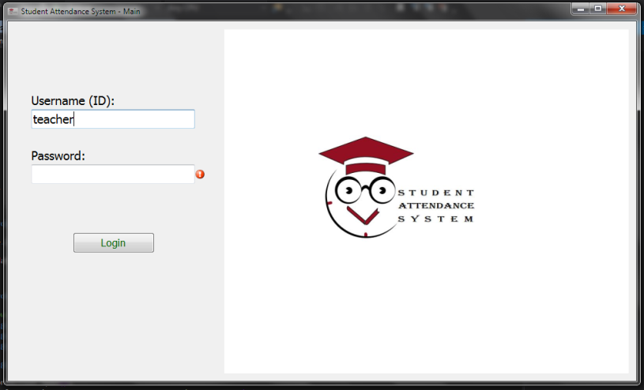

1. Error if you exceed the attendance limits

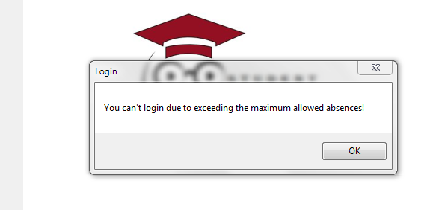

1. iF you are late

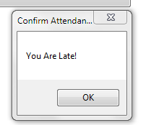

1. if you come early

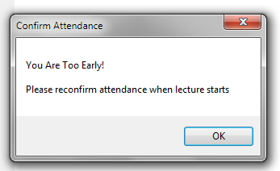

**System requirement :**

1. **visual studio 2015**
2. **my-Sql for the database**
3. **windows xp/7/8/10**
4. **1GB minimum ram .. dual core cpu**